

ABC Awards Level 2
Motor Vehicle Studies

Underpinning Knowledge Evidence Record

F/601/6051 Knowledge of Light Vehicle
Four Wheel Alignment

Learners Name
ABC Awards Registration Number
Centre Name
Assessor 1 Name
Assessor 2 Name


DECLARATION OF AUTHENTICITY

This declaration must be completed and signed by the learner and countersigned by the tutor / assessor and covers all evidence submitted for moderation.

Learner Name
Unique Learner Number (ULN) |  | ABC  Learner Reg. ID
Qualification Title
Centre Name

Learner statement of authenticity

Before signing please read the guidance below.

I confirm, that the attached assignment / portfolio is all my own work and does not include any work completed by anyone other than myself. I have completed the assignment / portfolio in accordance with ABC Awards’ instructions and within the time limits set by my centre.

Signature |  | Date

Centre confirmation of authenticity

On behalf of …………………………………….(insert centre name), I confirm that the above mentioned learner, to the best of my knowledge, is the sole author of the completed assignment / portfolio attached, and the assessments have been completed under the required conditions.

Signed |  | Date
Name
Title

Guidance for Learners

You have been asked to sign this Declaration of Authenticity and place it at the front of your portfolio or course work assessment. It confirms that the work you have submitted for assessment is your own and that you have not copied it from someone else or allowed another learner to copy it from you.

When preparing any course work it is good practice to undertake research using information from published sources. If you quote directly from these sources then this must be indicated in your work by using quotation marks and referencing the document from which the quotation was taken. You must then comment in your own words on any ideas expressed.

Assessors, internal verifiers and ABC Awards’ external moderators and verifiers are subject specialists who can spot the use of published materials that may be passed as your own words or ideas.
If you do copy words from a published source and do not indicate their reference you will be committing plagiarism. This is considered a form of cheating and may result in your assessment being declared void.

Contents

Task No | Title | Assessment Criteria
1 | Steering and suspension systems | 1.1, 1.2, 1.3 ,1.4
2 | Measuring four wheel alignment | 2.1,2.2,2.3,2.4, 3.1,3.2,3.3
3 | Testing completed adjustments | 4.1, 4.2, 4.3

Task 1 - Steering and suspension systems | Assessment Criteria 1.1, 1.2, 1.3 ,1.4

Describe the Ackerman Principle

Describe how the steering and suspension systems, have an effect on tyre wear and handling
Component | Tyre Wear | Handling
Wheel bearing
Ball joints
Springs
Dampers
Track rod ends

From the images below, describe the tyre fault and the possible causes
Type of wear | Fault Identification and possible causes
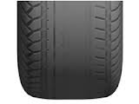
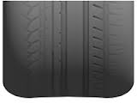
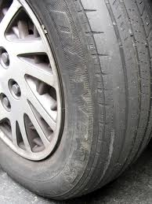

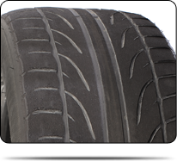

Task 2 – Measuring four wheel alignment | Assessment Criteria 2.1,2.2,2.3,2.4, 3.1,3.2,3.3

List tools and equipment used when carrying out four wheel alignment
Name of Tool / Equipment | Tool / Equipment safety checks | Explain how you would use the tool /Equipment safely and carry out calibration if required

State the pre-checks and results you must do before carrying out four wheel alignment

Equipment / System | Pre-check | Check results

Explain why it is important to take and record accurate measurements

Name the specialist tools in the images and their use when carrying out four wheel alignment
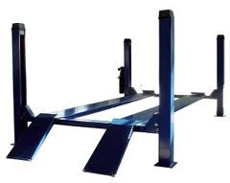
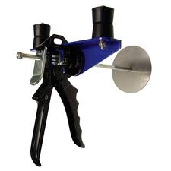

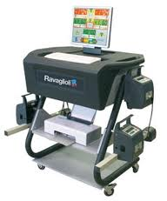

This vehicle has returned from the bodyshop after an accident, after placing it on the four wheel alignment machine, and noting the readings given in RED, what requires adjusting.
Wheel Alignment Report | Explain here the adjustments to carry out, and the correct sequence in which they are carried out.
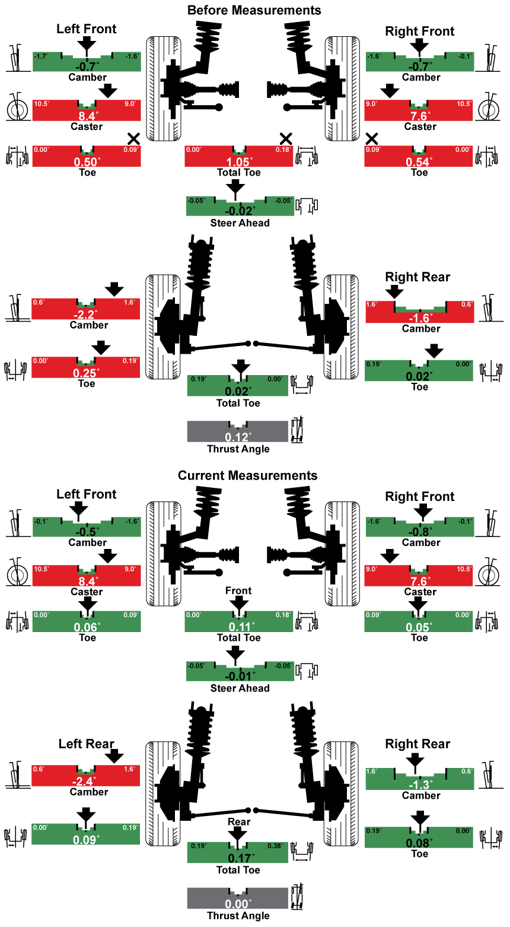

Describe why it is important to ensure any adjustments are within specification
Caster
Camber
Toe out on turns
Wheel alignment

Task 3 - Testing completed adjustments | Assessment Criteria 4.1, 4.2, 4.3

From the list, name and describe how to check the components function correctly
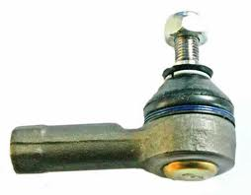
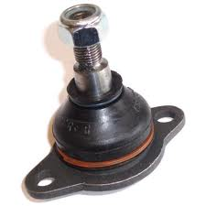

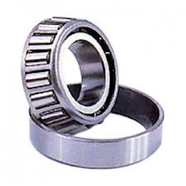
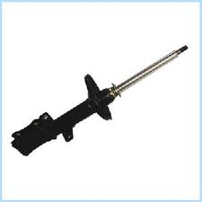
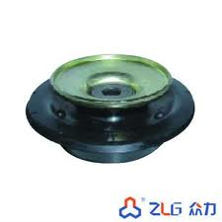

Explain why it is important to check the operation and safety of adjusted components before handing back to the customer

Explain the implications of adjustment on these electronic systems
Electronic System | Implication of Adjustment
ABS Sensor
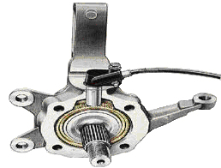
Electronic Suspension
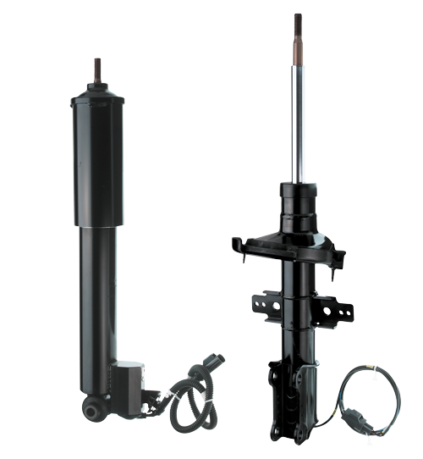

Unless otherwise stated e.g. for some entry level qualifications, learners can work together but should identify sections which are their own work.

